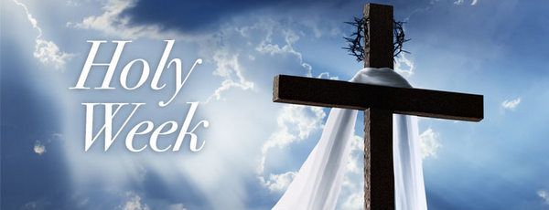

Sts. Peter and Paul Catholic Church
Holy Week & Easter Services
2021
Palm Sunday | March 28th | Regular Weekend Schedule
Monday | March 29th | 7:30 AM Mass
Tuesday | March 30th | 11:00 AM Chrism Mass at Archdiocesan Pastoral Center
 |  | 6:00 PM Mass
Wednesday | March 31st | 8:00 AM Mass
Holy Thursday | April 1st | 7:00 PM Mass of the Lord’s Last Supper
 |  | Washing of the feet and Eucharistic Procession are during Mass.
 |  | Adoration will continue in Church after Mass until midnight.
Good Friday | April 2nd | 3:00 PM – Celebration of the Lord’s Passion
 |  | 7:00 PM – Living Stations of the Cross
Holy Saturday | April 3rd | 7:00 PM – Easter Vigil Mass
 |  | Candidates reception of the Sacraments
Easter Sunday | April 4th | 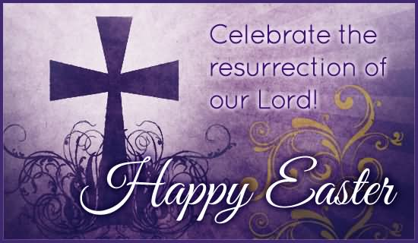  Mass 6:30 AM  8:00 AM  9:30 AM  11:00 AM

